Asdfasdfasdffdssfddas

3233 South University Drive  Fargo, ND 58104  Website: www.sendcaa.org

Phone: (701) 232-2452  Toll free: (800) 726-7960  Fax: (701) 298-3115



**SouthEastern North Dakota Community Action Agency**

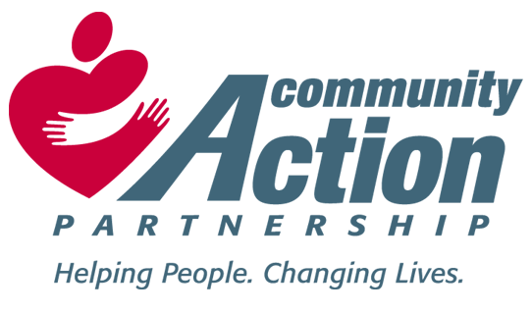

**Youth IDA Referral Form**

Referring Agency: _________________________Phone:____________________

Referred by: _____________________ Email: ________________________________

Name of Client: ________________ Client Phone Number_____________________

Age of Client: __________ Using savings for: _________________________

How long have you worked with this client: _____________________

Briefly describe why you feel this client would be a good candidate for the Youth IDA program:

____________________________________________________________________________________________________________________________________________________________________________________________________________________________________________________________________________________________________________________________________________________________________________________________________________________________________________________________________________________

Staff Signature______________________ Date_____________________

**Release of Information:**

I hereby give ______________________ permission to release or share information

(Agency)

regarding this referral to SENDCAA staff. This will be in effect for 1 year from signature date.

Client signature________________________ Date_______________________

Please return to Lindsey at SENDCAA, 3233 South University Dr. Fargo, ND 58104

[lindseyo@sendcaa.org](mailto:lindseyo@sendcaa.org) 701-232-2542 phone, 701-298-3115 fax